**Background**

James is a math teacher and also leads the Travel and Leisure club at his school. Next month, he will lead the club on a special one month long trip to either one of the below five favorite cities in the US as voted by the club.

New York City

San Francisco

Jersey City

Boston

Chicago

In order to determine which city to visit, the club has decided to use pizza as the deciding criteria. Pizza is also the club’s favorite food and in order to try as many pizzas as possible, they would like to visit the city with the most pizza restaurants. The problem is how do you determine which city has the most pizza locations?

**Data Science applied**

Fortunately, James is also a part-time data scientist. He believes he can apply his skillsets to this "nice-to-have" problem by collecting, analyzing, and researching pizza restaurants in those cities. James will use FourSquare API to collect data about pizza restaurants in New York, San Francisco, Jersey City, Boston and Chicago. Factors would include pizza location density and proximity. This analysis will allow him and the club to decide on which city to visit.

**Analysis and Research**

It looks like New York and Jersey City are the densest cities with Pizza restaurants. Let's use basis statistics to measure density. First would be the mean location of the pizza restaurants which should be near to most of them if they are really dense or far if not. Second would be the average of the distance of the venues to the mean coordinates.

**New York, NY**

Mean Distance from Mean coordinates

0.022815787835705436

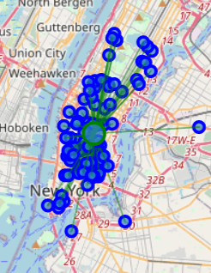

**Chicago, IL**

Mean Distance from Mean coordinates

0.058020338732588994

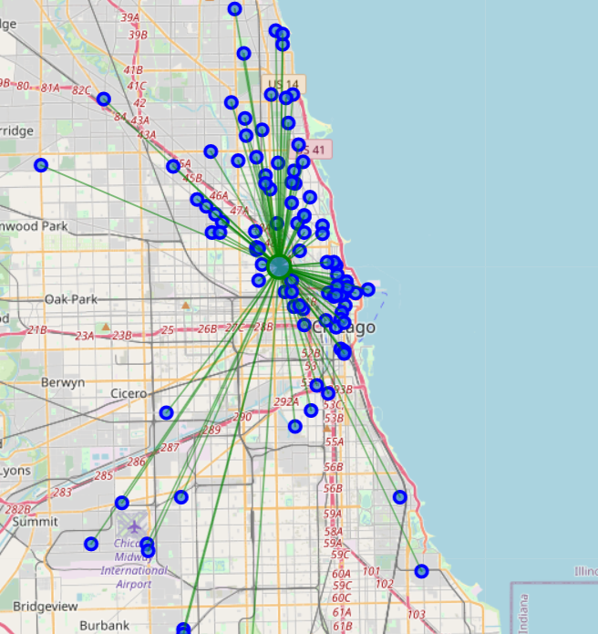

**San Francisco, CA**

Mean Distance from Mean coordinates

0.02873219591073641

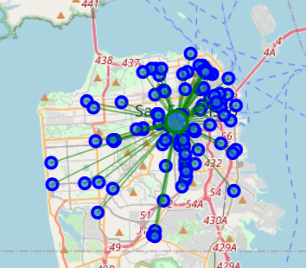

**Jersey City, NJ**

Mean Distance from Mean coordinates

0.019095697752698728

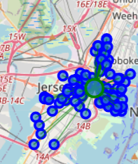

**Boston, MA**

Mean Distance from Mean coordinates

0.03533376366408385

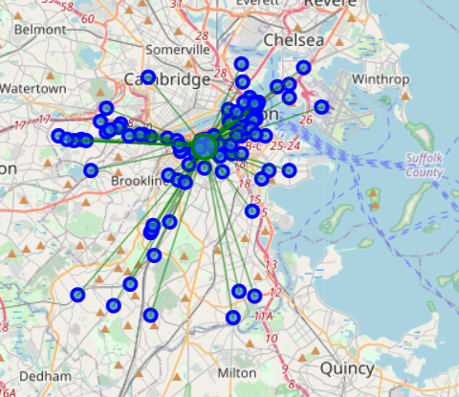

**Conclusion**

No surprise, but it looks like New York is his best option. And in addition, 3rd best place is Jersey City,

which is also in close proximity to NYC. So now the club can enjoy pizza from two cities!